How to create an Alma Analytics report of all courses which do not have a reading list | 

In order to create an Alma Analytics report of all courses which do not have a reading list you may do as follows:

ONE
Create a report in the Course Reserves subject area

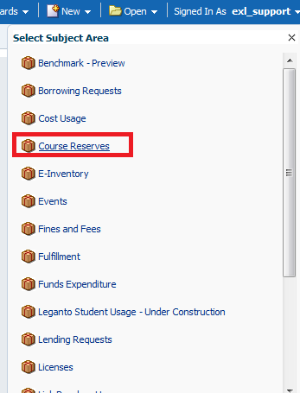

TWO
In the criteria tab retrieve only the course code.
Filter by the course code is not null
Filter by the reading list code is not null.
This will give a list of all courses which do have a reading list
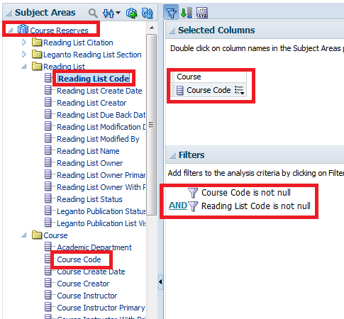

THREE
Save the report (for example) as “All course codes which have a reading list”

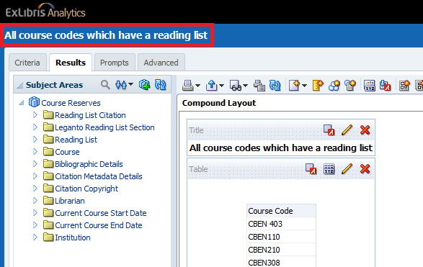

FOUR
Create another report in the Course Reserves subject area.
Display whatever fields you want, for example the course code and the course name.

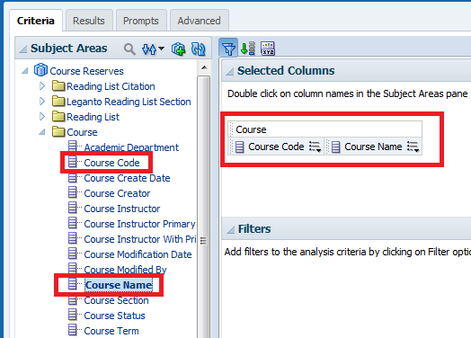

FIVE

Filter the course code so that we will get only the course codes which are not in the report we previously made called “All course codes which have a reading list”. This way we will have “All courses which do not have a reading list”.
Filter the course code and choose “Is based on results of another analysis”.

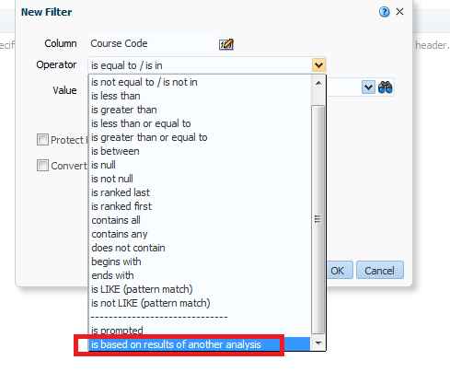

SIX
Choose the report we made above called “All course codes which have a reading list”.
Choose relationship “is not equal to any”.
Choose column “Course Code”.

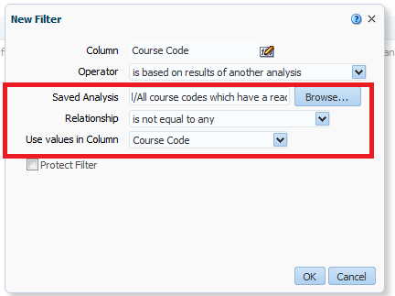

SEVEN
See results. We will randomly now check the 1st, 5th and 10th result to make sure in Alma that they really no not have a reading list. We see that in fact they do not have a reading list. We have successfully retrieved all courses which do not have a reading list.

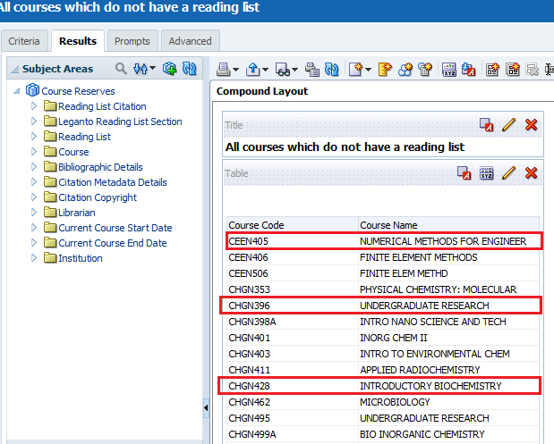

Here is CEEN405:

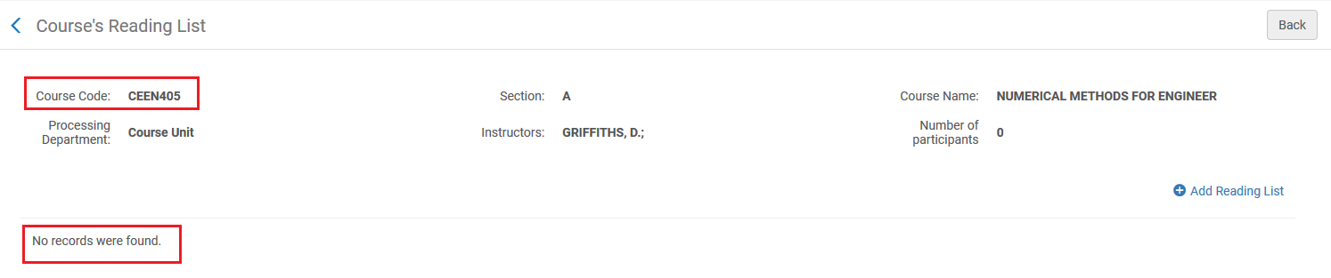

Here is CHGN396:

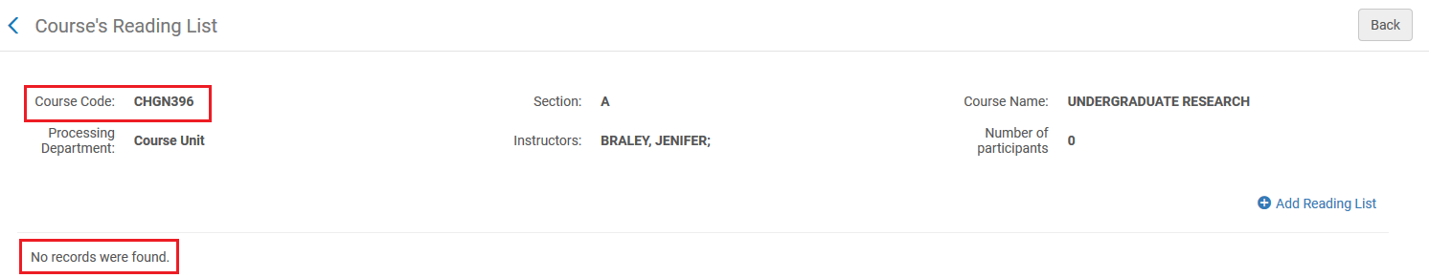

Here is CHGN428:

